Subhasis Satpathy 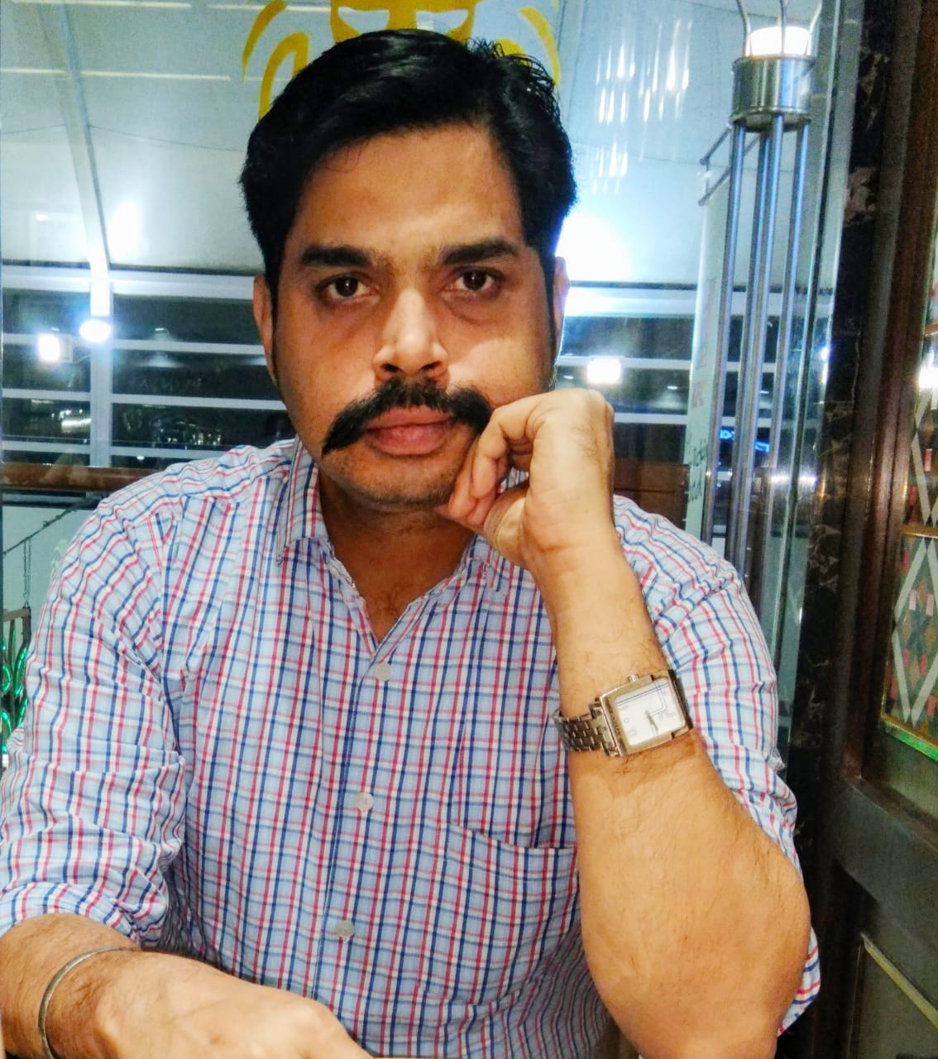

Address – 9,1st Floor ,Indersingh Appartment, Khasra No-408/1, Ignou Rd.,Neb Sarai New Delhi 110068

Cell - +91 9555643212 Skype ID :s.satpathy240281 Email – jobs.subhasis@gmail.com

PROFESSIONAL SYNOPSIS
- A competent HR Professional with 11 years of experience with Franchise Consulting, Manpower consulting ,Retail Industry performing and managing various cross functional and HR functions –HR Generic, Talent Acquisition ,Sales Hiring, Bulk recruitment & Employee relations.

PROFESSIONAL EXPERIENCE
- Franchise India Brands ltd. May 2012 to till date Manager-HR

Responsibility Undertaking: Talent Acquisition / Recruitment (Hire to Retire )

- Responsible for hiring at for Franchise India ltd (For 10 Branches)for Franchisee Development, New Channel Development, Channel Management ,Investor Acquisition, Investor Relationship, Business Development, Corporate Sales, Retail & Commercial leasing, CRM, Marketing and Communication, Content Writer, BPO, Strategy Consultants, and Research related positions
- Hired from different industry segments-Job Portal, Head hunting, Social media hiring, references
- SPOC for campus hiring process.
- Consistent execution of recruitment plan to ensure the right quantity and quality of talent.
- Taking care of End to End recruitment i.e Hiring to Exit interview.

Joining, On boarding & Induction

- Completing the joining formalities and Onboarding the candidates.
- Planning and organizing orientation programs for all new joiners at the corporate office.
- Buddy Assigning for new joinee.

Stakeholder Management

- Working with business leaders at various levels of the organization; consult to understand the business needs for full lifecycle recruiting.
- Discussing manpower requirements for different levels.

MIS Reporting and other operational activities

- Preparing HR Monthly Reports and presenting the same to the Stakeholders, Head HR.
- Marinating various documents like manpower requisition forms, reference check forms , exit interview forms etc.
- Exit interview forms .

- Spectrum Placements Apr 2011 to May 2012 Sr. Recruitment Executive

Responsibility Undertaken: Recruitment / Talent Acquisition for Retail, Consumer Durables, FMCG, Hospitality, and Event Management Domains. For junior level position to Middle level positions. For major clients handled Encompass Events, Healthkart, Marico, Oriflame, Agrotech Ltd,Titan, BOSE Consumer Electronics, Khadims, Carrier etc

- Kent Technologies Jan 2007 to Jan 2009 HR Executive

Responsibility Undertaken: Recruitment & HR Operations

ACTIVITIES & NOTABLE ACCOMPLISHMENTS
- Received MAD award in 2014,2016,2018 for good performance.
- Winner of Silver medal for 2009-11 batch for academic excellence.
- Active Member of Sanjeevani, Orissa for Blood Donation.

EDUCATION
PGDM (HRM) from Fortune Institute for International Business, New Delhi ,2011 with 7.96CGPA
MCA from G M College (Auto),SBP, Orissa ,2006 with 75 % .
BSC from Rajendra College(Auto),BGR, Orissa ,2003 with 68 %(Distinction

PERSONAL MINUTIAE
Languages Known - English ,Hindi and Oriya
Computer skills - Packages- Microsoft Office Others: Recruitment Portals (naukri.com,timesjobs.com)

DECLARATION
I hereby declare that the details furnished above are true to the best of my knowledge and I promise to work with sincerity if I am selected.

Yours Truly,
Subhasis Satpathy

